Meeting 24/03 – Prof Manning

Remember: treatment and instrument capture region’s degree of exposure to trade protection (tariffs)
- Employment share normalises population, how employment responds to population increases is captured by the share. Log(population) and log(employed no) on LHS allows them to both vary separately, holding population fixed

- Log might not actually be that different – log population count. Kind of actually similar expected results. Compare the coefficients multipled – see sheet.
Decide on which ones to present

- There’s also the small possibility of the weightings of different observations not being the same across regressions – anomalies are always weighted more (think about what a regression actually does - OLS)

- Gains for including a theoretical model – also shows a wider degree of skills and understanding; two labour markets – male and female (potentially in different industry groups but is this what is seen in the data, men and women separating into different industry groups?), joint at the household level, could even say potentially joint at the industry level.
I think if include a good theoretical model that works -> sig gains and adv

What are the assumptions I’m making?
India – a social cost to women working, animus (potential discrimination by employers – incorporate Becker’s model of discrimination)
See what model Gaddis and Pieters have – they don’t have one, refer to the literature of existing trade models
Will have to work out how to interconnect the model, specification and ultimately results

- Look into dataset with exports: would have to weight by trading partners – how much is exported to that country interacted with tariff rate – maybe someone has constructed this dataset

Plan of action:
- Write up + add in theoretical model
- Work on writing up the rest of the paper
- If time, add robustness checks – exports, consider how they vary by product group

What about robustness checks on the empirical design? Jackknife sampling.
Motivating the assumption of exogeneity of the shocks – Topalova?
Model ideas and literature

- My main focus is on the gendered perspective, and incorporating trade element – how this could affect employment and production more generally

- Manning: Two labour markets, for men and women in different industry groups (see in the data: how many men and how many women – plot graph)
- Men and women potential converse relationship; having a household model where FLFP is a function of own wage and husband’s wage. Incorporate social cost to household/woman from working. Added worker effect
- Firm/industry - animus – cost to employer, discriminate against women. Can put as a limitation of a static model; over time, exposure to working women reduces social cost and can erode stigma.
- Women face trade-off between fertility (marriage – documented in the literature that FLFP drops off after marriage more in India) and participating in labour market
- Consider a Becker unitary model (each spouse is not necessarily maximising their own utility – but more the household jointly maximising (makes more sense in the Indian context – household, typically husband/elders have greater weight in decision process, difficult to give individual agents autonomy).

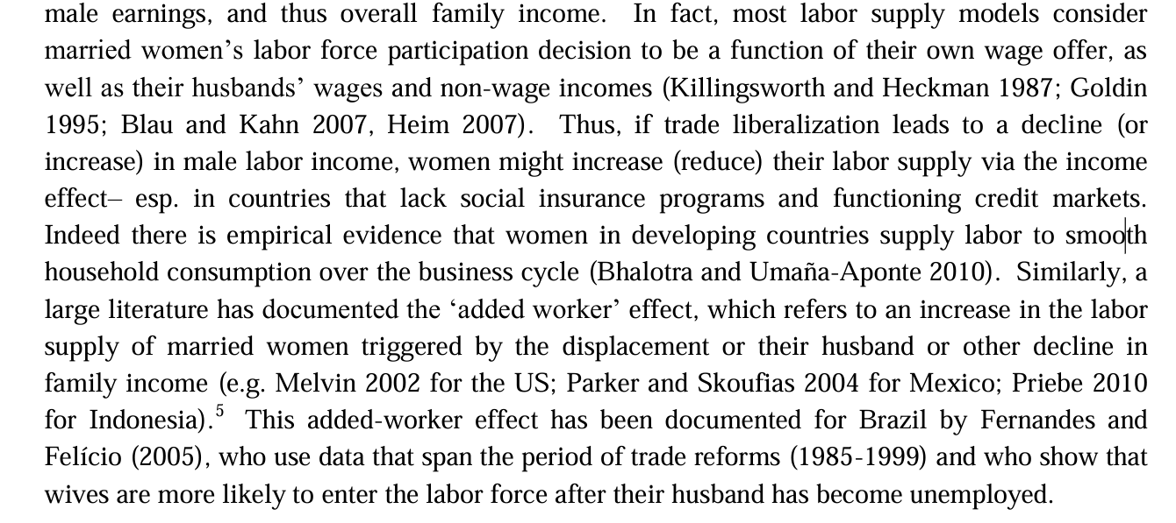

Literature of models to look at:
Cross al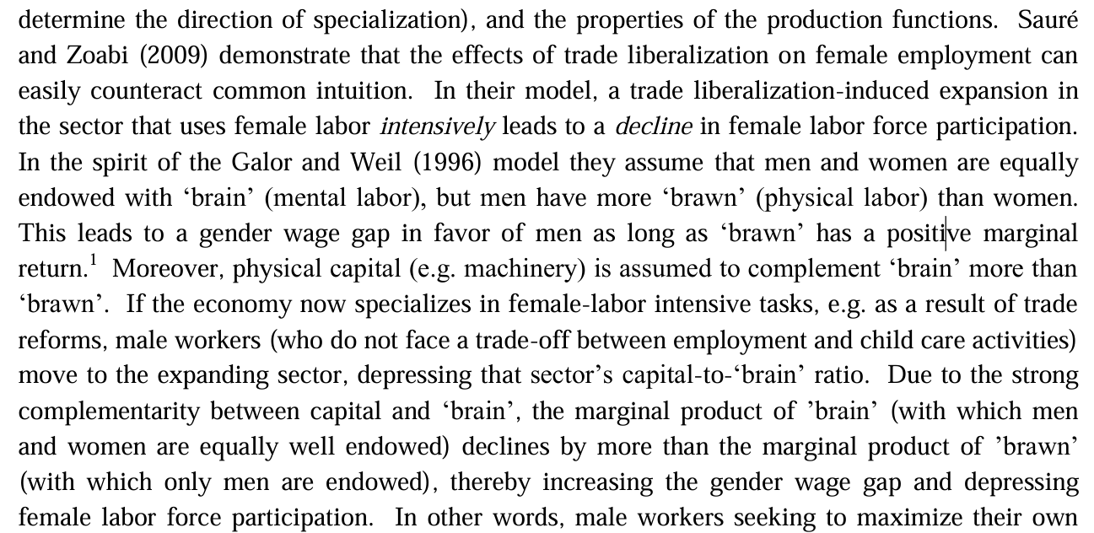
- But I find something suggestively opposite in my results; where increase in trade protectionism of region for female-workers decrease in female employment.
- Women in all countries are virtually clustered in specific industries/occupations globally. In my data all industries are dominated by men, but proportion of industry that is female increases from 1991 to 2001 across all industries except mining.

Office hours: Michael Gmeiner 28/03

- Wanted to clear understanding of why number of shocks needs to be sufficiently large: (in the case where shares are industries) - no particular industry is driving the result and variation in SS instruments.

`Tariffs as good as randomly assigned to industries: tariffs are not systematically higher or lower in industries which are clustered in regions facing labour supply/demand shock. Share-weighted average of random shifts is itself as good as random.’

If many industries, each region will contribute a smaller fraction of employment to a particular industry, more likely that region’s characteristics are not correlated to industry’s shock.

Having a large number of shocks – shocks to shares less likely correlated to local factors.

But also don’t want number of shocks to get too large – LLN, if every region’s weighted average shock is similar and has little variation, you don’t have sufficient identification.

- I don’t have sufficient number of industry groups – I have ten: so jackknife resampling / leave-one-out construction of the shifts.
BHJ: appendix: ‘open q of whether can help with exog shifts.’ Leave out a region, but they might be doing this at the shock level.

Essentially by leaving out each industry (in the instrument only), and now incomplete shares control factors in the left out industry, and estimating on remaining sample – iteratively doing this for each industry – diagnostic for if any one particular industry is driving the results. Not biased.

- When I run my leave-one-out regressions, I get large, statistically significant negative results for one industry group – wholesale, retail and trade – which also has the largest weighting on the shock (0.29).
- Wholesale, retail and trade is the one industry group where the instrument tariff and treatment tariff go in the opposite direction (i.e. tariff drops from 1991 – 1997, like all other industries but then rises from 1997 to 2001 to the point where tariff in 2001 is higher than 1991).

- MG: Looks like you predominantly have two choices; if you think wholesale, retail and trade are unbiased and unrepresentative, you can leave the industry group out and re-run all of your results (it’ll be ok!). Or you can include this as a robustness check/potential limitation and mention it as a disclaimer.

